ATAR PHYSICS YEAR 11 2019 

Linear Motion Test No. 2 Name ________________

Total Marks __________________ /55

Question 1 ( 1 mark)

Which of the follow options is the law of conservation of momentum? ________________

A The product of the momentum before a collision is equal to the product of the momentum after it.

B The product of the momentum before a collision is always greater than the product of the momentum after it.

C The sum of the momentum before a collision is equal to the sum of the momentum after it.

D Momentum can neither be created nor destroyed; it can only change form.

Question 2 ( 2 marks)

A 1500 kg vehicle is travelling at 20 m s–1. Calculate the average net force would be needed to stop the vehicle in 4.0 s?

Question 3 ( 4marks)

The graph shows how a force applied to an initially stationary 5.0 kg bowling ball varied with time.

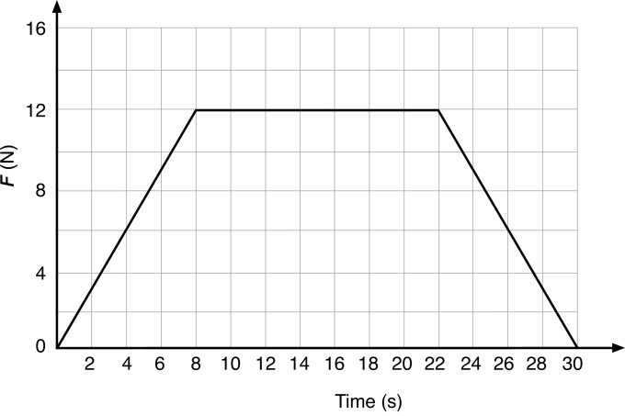

1. Use the graph to determine the total impulse exerted on the bowling ball over the 30 s? (2 marks)
2. Determine the change in momentum ( 1 mark)
3. Determine the final speed of the bowling ball? (1 mark)

Question 4 (1 mark)

A 10 tonne truck collides with an unoccupied and stationary Mini. According to Newton’s third law, which of the following is correct? _______________

A The truck applies the same magnitude force to the Mini as the Mini applies to the truck.

B The truck applies a greater magnitude force to the Mini than the Mini applies to the truck.

C The truck applies a smaller magnitude force to the Mini than the Mini applies to the truck.

D The truck applies the force to the Mini while the Mini applies no force to the truck.

Question 5 (4 marks)

A high-velocity 8.10 g rifle bullet, travelling horizontally, lodges in a 2.00 kg wooden block, at rest on a horizontal, frictionless plane. The block, with the bullet stuck inside, reaches a velocity of 7.00 m s–1 in the same direction as the bullet.

a Determine the impact velocity of the bullet. (2 marks)

b Calculate the impulse on the block. (2 marks)

**Question 6 (11 marks)**

A physics student studies the car she has just bought to get to university each day. The car has a mass of 945 kg, can go from 0 to 60.0 km h-1 in 6.50 s, and is painted bright yellow.

a Calculate the acceleration of the car. (2 marks)

b Calculate the force causing the car to accelerate. (2 marks)

**c** Calculate the power used by the car during this acceleration (2 marks)

d Calculate the weight of the car. (2 marks)

e While she is in class a 5.00 tonne truck collides with her stationary car, which is parked on the side of the road. On the diagram below, use labelled vector arrows to accurately show all the forces acting on the truck and on the car. (3 marks)

Question 7 ( 4 marks)

A bungee jumper of mass 70.0 kg jumps from a height of 110 m. Before reaching the bottom of the jump, at a height of 30.0 m, her cord starts to stretch so that she is travelling at a speed of 25.0 m s–1. How much of her energy was converted into heat and the stretching of the cord? Express this as a percentage. (4 marks)

Question 8 ( 3 marks)

A 1250 kg car travelling at 70 km h–1 slides off the road and into a tree, coming to a complete halt. How much work has been done on the car in bringing it to a halt?

Question 9 (14 marks)

The diagram below shows a new section of roller-coaster track that is being tested. The mass of an empty carriage is 350 kg. The carriage is momentarily at rest at point R before it rolls towards point S. Ignore any effects due to friction when answering the following questions.

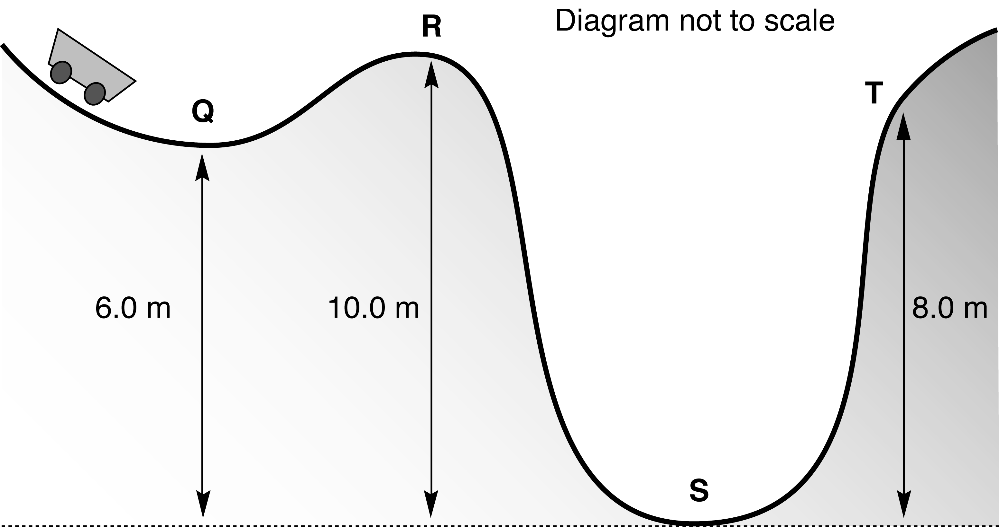

a What is the gravitational potential energy of the carriage at point R? (1 mark)

b What is the kinetic energy of the carriage at point R? (1 mark)

c What is the kinetic energy of the carriage at point S? (1 mark)

d What speed is the carriage travelling when it passes through point S? (3 marks)

e The carriage passes through point S, heading towards point T. Calculate the speed of the carriage as it passes through point T. (4 marks)

f During another trial run, the carriage travels through point Q with enough speed so that it can just reach point R. What is the speed of the carriage at point Q during this trial? (4 marks)

**Questions continued on next page**

Question 10 ( 8 marks)

A 35.0 kg girl is jumping on a trampoline. She is travelling at 6.00 m s–1 when she hits the trampoline at 45° to the horizontal travelling to the right and bounces back up with a velocity of 4.20 m s–1 at 45° to the horizontal travelling to the right.

a Calculate the initial momentum of the girl (1 mark)

b Calculate the change in momentum of the girl. Use north, south, east and west to designate direction, where N–S are up–down respectively, and E–W are right–left. Draw a suitable vector diagram to aid in your calculation (7 marks)

Question 12 ( 3 marks)

Explain the similarities and differences between an elastic and in elastic collision.